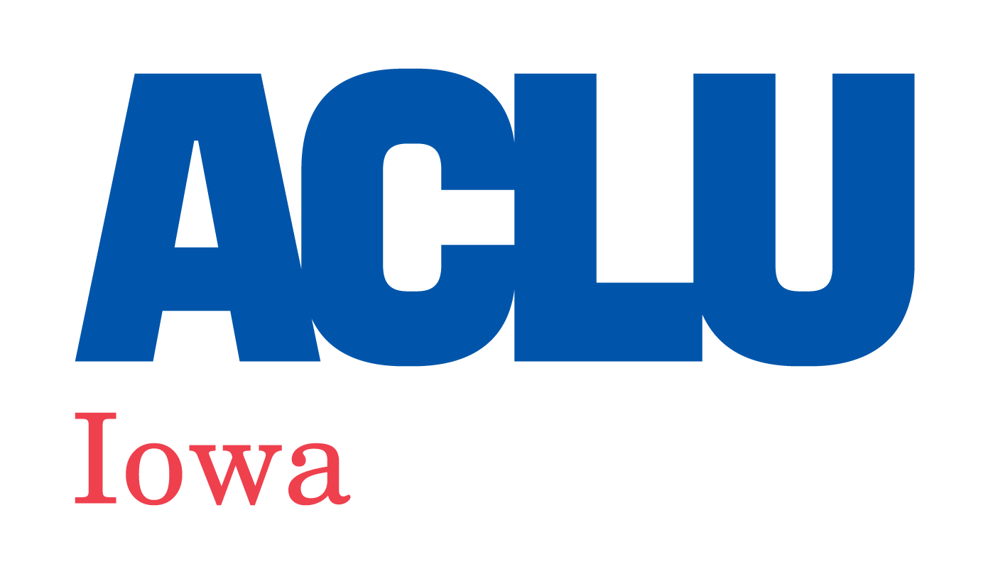
505 Fifth Ave., Suite 808, Des Moines, IA 50309
www.aclu-ia.org

Robert Mannheimer Youth Advocacy Award Nomination Form

The Robert Mannheimer Youth Advocacy Award will be given to one applicant age 14 to 19 at the time of nomination. The $500 cash award is given to a young person who has demonstrated a passion and a record of advocacy for civil liberties issues like racial justice, free speech, free expression, LGBTQ issues, immigrants’ rights, gender equality, religious freedom, privacy issues, disability rights, and more.

To submit your nomination, email the completed form to outreach@aclu-ia.org or send via mail to the following address: ACLU of Iowa, c/o Mannheimer Award, 505 5th Ave., #808, Des Moines, IA 50309. Your application must be received by Sunday, January 15, 2023.

For more information or details, visit our website (www.aclu-ia.org/awards) or email outreach@aclu-ia.org.

*******

Nominee Name:

Date of Nomination:

Postal Address of Nominee:

Phone Number of Nominee:

Email Address of Nominee:

Name of Nominator (leave blank if you are nominating yourself):

Relationship to Nominee:

Postal Address of Nominator:

Phone Number of Nominator:

Email of Nominator:
*******

Questions: You may answer these questions in writing or by submitting a video, whichever you prefer.

How did you hear about the Mannheimer Youth Advocacy Award?:

Please tell us why you feel the nominee is a good candidate for the Mannheimer Award (or why you are a good candidate for the award if you are nominating yourself). If answering in writing, use the word count you feel is needed. We suggest somewhere between 500 to 1,000 words. Use a separate page if desired.

We also encourage you to attach or share additional documentation like newspaper articles, letters of reference, and any relevant work (writing, websites, videos, etc.) created by the honoree.

